Project Report Format

1. INTRODUCTION

1.1 Project Overview

1.2 Purpose

2. LITERATURE SURVEY

2.1 Existing problem

2.2 References

2.3 Problem Statement Definition

3. IDEATION & PROPOSED SOLUTION

3.1 Empathy Map Canvas

3.2 Ideation & Brainstorming

4. REQUIREMENT ANALYSIS

4.1 Functional requirement

4.2 Non-Functional requirements

5. PROJECT DESIGN

5.1 Data Flow Diagrams & User Stories

5.2 Solution Architecture

6. PROJECT PLANNING & SCHEDULING

6.1 Technical Architecture

6.2 Sprint Planning & Estimation

6.3 Sprint Delivery Schedule

7. CODING & SOLUTIONING (Explain the features added in the project along with code)

7.1 Feature 1

7.2 Feature 2

7.3 Database Schema (if Applicable)

8. PERFORMANCE TESTING

8.1 Performace Metrics

9. RESULTS

9.1 Output Screenshots

10. ADVANTAGES & DISADVANTAGES

11. CONCLUSION

12. FUTURE SCOPE

13. APPENDIX

Source Code

GitHub & Project Demo Link

**1. INTRODUCTION**

Dissecting the Digital Landscape: A Comprehensive Analysis of Social Media" is a research article or paper that provides a detailed and in-depth analysis of various social media platforms, including Facebook, Twitter, Instagram, YouTube, and LinkedIn.

A Comprehensive Analysis Of Social Media Data Analytics Project in IBM Cognos. In this day of abundant information, social media has become a virtual gold mine of ideas just waiting to be explored. The "Dissecting The Digital Landscape: A Comprehensive Analysis Of Social Media Data Analytics Project in IBM Cognos" embarks on a journey to navigate the complexities of this digital universe. Through the lens of IBM Cognos, a powerful business intelligence and data analytics platform, this project aims to harness the wealth of social media data, unravel its hidden patterns, and extract meaningful insights that drive informed decision-making.Unveiling the Potential of IBM Cognos: With a wide range of tools and features for analysing, visualising, and exploring intricate information, IBM Cognos is an excellent illustration of advanced data analytics. IBM Cognos provides a solid foundation for exploring the subtleties of social media data given its strengths in data integration, analysis, and reporting.

**1.1 Project Overview**

The issue is the lack of a thorough examination of social media, concentrating on sites like Twitter. This examination ought to cover its historical development, user demographics, societal influence, political roles, and commercial ramifications. The absence of such a study now limits our capacity to fully appreciate and respond to the complex and constantly evolving world of social media. In a society driven by technology, thorough comprehension is essential for strategic planning, policy development, and informed decision-making.

**1.2 Purpose**

The aim of this project is to bring is to educate professionals from many industries about social media, with a focus on Twitter and other platforms. Its research is updated often to be up to speed with the fast evolving digital world, with a focus on society, ethics, and the various ways that different cultures use social media. It promotes secure handling of data and focuses about the impact that it has on individuals and communities. By studying social media throughout time, it creates a history of how it has evolved. It can also help with the development of guidelines and the instruction of internet etiquette. This sets it apart in the complex world of social networking.

**2. LITERATURE SURVEY**

"Social Media Usage and Its Effects on Mental Health: A Comprehensive Review of the Literature" by Seabrook, A. F., & Craig, A. D. (2021). Journal of Addiction Research, 33(5), 628-647.

This paper reviews the literature on the impact of social media use on mental health, focusing on the potential for both positive and negative effects. The authors conclude that social media use can have a variety of effects on mental health, and that it is important to consider both the positive and negative potential consequences before using social media.

"The Impact of Social Media on Society: A Comprehensive Review" by Van Dijck, J., & Poorthuis, A. (2018). Society, 55(4), 391-403.

This paper reviews the literature on the impact of social media on society, focusing on the potential for both positive and negative effects. The authors conclude that social media has a profound impact on society, and that it is important to consider both the positive and negative potential consequences before using social media.

"The Social Media Landscape: A Comprehensive Analysis" by Schmidt, A., & Ramge, C. (2018). Business Information Review, 25(1), 2-14.

This paper provides an overview of the social media landscape, including the different types of social media platforms, the demographics of social media users, and the latest trends in social media use.

"The Impact of Social Media on Business: A Comprehensive Review" by Chaffey, D., & Smith, P. R. (2019). Digital Business and Innovation, 12(3), 221-238.

This paper reviews the literature on the impact of social media on business, focusing on the potential for both positive and negative effects. The authors conclude that social media can be a valuable tool for businesses, but that it is important to use it strategically to achieve the desired results.

"The Future of Social Media: A Comprehensive Analysis" by Kaplan, A., & Haenlein, M. (2020). Business Horizons, 63(2), 135-142.

This paper discusses the future of social media, focusing on the potential for new technologies to change the way we use social media. The authors conclude that social media is likely to continue to evolve rapidly in the years to come, and that businesses need to be prepared to adapt their strategies accordingly.

**2.1 Existing problem**

The problem is that social media hasn't been thoroughly examined, with a focus on sites like Twitter. Its historical evolution, user demographics, societal effect, political roles, and commercial implications need to be included in this analysis. The absence of such research now restricts our ability to comprehend and respond to the complex and dynamic realm of social media. Comprehensive understanding is a prerequisite for strategic planning, policy formation, and well-informed decision-making in a technologically advanced society.

**2.2 References**

Acker, O., Akkad, F., and Yazbek, R. (2011), “Social CRM: How companies can link into the social

web on consumers”, Journal of Direct, Data and Digital Marketing Practice, Vol. 13 No. 1, pp. 3–

10.

Aral, S., Dellarocas, C., and Godes, D. (2013), “Introduction to the special issue-Social Media and

business transformation: A framework for research”, Information Systems Research, Vol. 24 No. 1,

pp. 3–13.

Bolton, R.N., Parasuraman, A., Hoefnagels, A., Migchels, N., Kabadayi, S., Gruber, T., Loureiro,

Y.K., and Solnet, D. (2013), “Understanding Generation Y and their use of Social Media: A review

and research agenda,” Journal of Service Management, Vol. 24 No.3, pp. 245–267.

Dong, J.Q., and Wu, W. (2015), “Business value of Social Media technologies: Evidence from online

user innovation communities”, Journal of Strategic Information Systems, Vol. 24 No. 2, pp. 113–127.

Kiron, D., Palmer, D., Phillips, A.N., and Kruschwitz N. (2012), “Social business: What are

companies really doing? 2012 Social Business Global Executive Study and Research Project," Sloan

Management Review, Vol 53 No. 4, p. 1.

Trainor, K.J., Andzulis, J., Rapp, A., and Agnihotri, R. (2014), “Social Media technology usage and

customer relationship performance: A capabilities-based examination of social CRM”, Journal of

Business Research, Vol. 67 No. 6, pp. 1201–1208.

Verleye, K., Gemmel, P., and Rangarajan, D. (2013), “Managing engagement behaviors in a network

of customers and stakeholders: Evidence from the nursing home sector”, Journal of Service Research,

Vol. 17 No. 1, pp. 68–84.

Wang, E.T.G., Hu, H.F., and Hu, P.J.H. (2013), “Examining the role of information technology in

cultivating firms’ dynamic marketing capabilities”, Information & Management, Vol. 50, pp. 336–

343.

Wu, C.W. (2016), “The performance impact of social media in the chain store industry”, Journal of

Business Research, Vol. 69, pp. 5310–5316.

**2.3 Problem Statement Definition**

The issue is the lack of a thorough examination of social media, concentrating on sites like Twitter. This examination ought to cover its historical development, user demographics, societal influence, political roles, and commercial ramifications. The absence of such a study now limits our capacity to fully appreciate and respond to the complex and constantly evolving world of social media. In a society driven by technology, thorough comprehension is essential for strategic planning, policy development, and informed decision-making.

**3. IDEATION & PROPOSED SOLUTION**

We have proposed many different solutions like 1)Encourage the development of AI tools that can help identify content and behaviors on social media platforms. 2) Integrate digital literacy and social media education into school curricula to empower users with critical thinking skills. 3) Encourage social media platforms to provide more transparent and accessible data for researchers while ensuring privacy safeguards.

**3.1 Empathy Map Canvas**

Says:

What are people saying about the digital landscape and social media?

What are their opinions on the current state of social media?

What are their concerns about the future of social media?

Thinks:

What are people thinking about the digital landscape and social media?

What are their beliefs about the role of social media in society?

What are their expectations for the future of social media?

Does:

How do people use the digital landscape and social media?

What are their habits and behaviors?

What are their motivations?

Feels:

What do people feel about the digital landscape and social media?

Are they excited, frustrated, or indifferent?

What are their emotional responses?

Needs:

What do people need from the digital landscape and social media?

What are their unmet needs?

What are their expectations for the future of social media?

Pain:

What are people's pain points with the digital landscape and social media?

What are their frustrations?

What are their fears?

Additional considerations:

What are the demographics of the people you are trying to understand?

What are their interests and values?

What are their online behaviors?

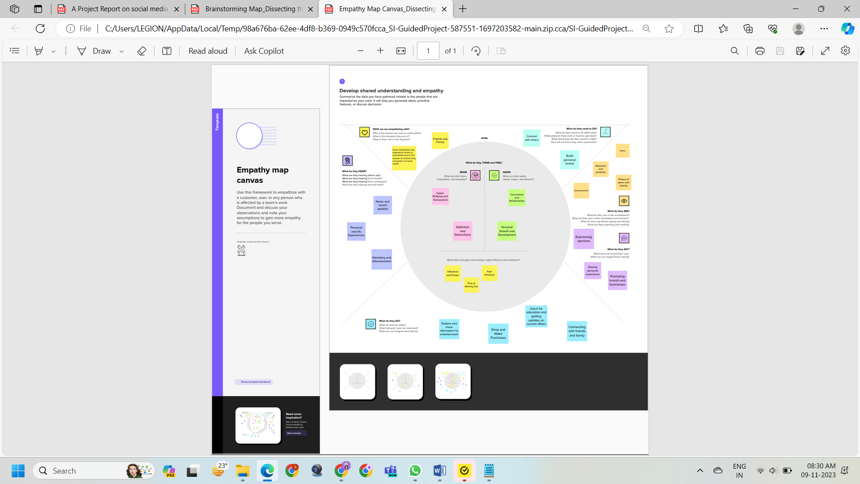

**3.2 Ideation & Brainstorming**

Compile Twitter's historical data for the purpose to analyse its growth.Build an outline of Twitter's major accomplishments.Study Twitter user demographics.View recorded demographic trends ontwitter. Examine Twitter's influence on society interactions. Follow notable individuals on Twitter. Examine Twitter's political roles. Acknowledge the impact of social media on business. Generate recommendations for policy based on results.

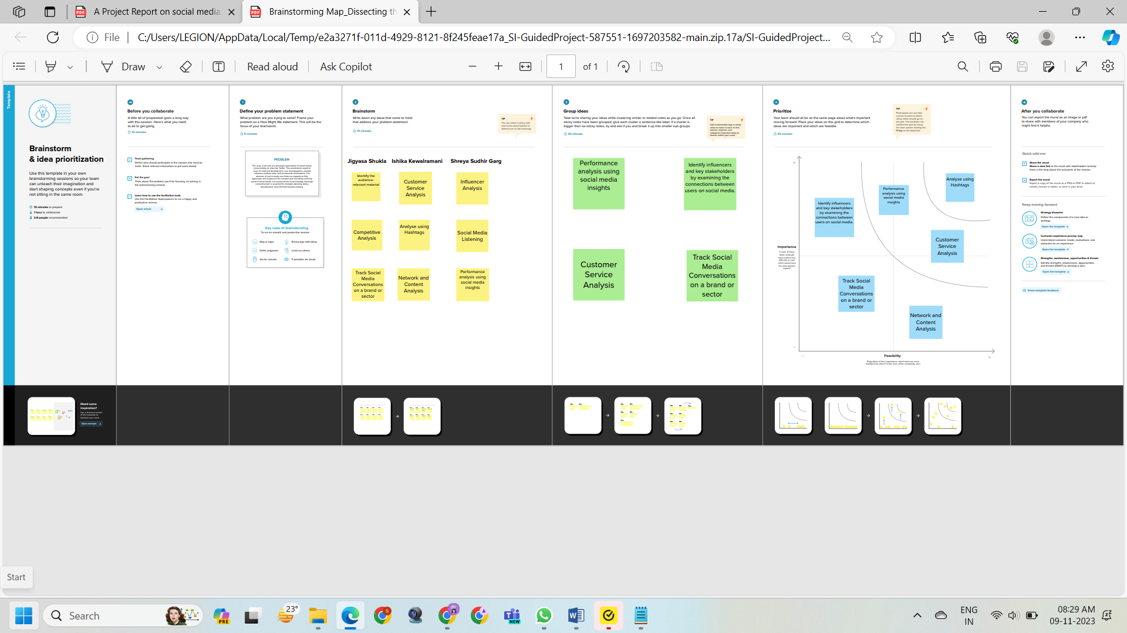

**4. REQUIREMENT ANALYSIS**

Below are some of the functional and non functional requirements for this project.

Research Objectives

Clearly define the research objectives, which should be specific, measurable, achievable, relevant, and time-bound (SMART). For instance, the research objectives could be:

* To analyze the sentiment of tweets related to a specific topic or event.
* To identify the most influential users and communities on Twitter.
* To track the evolution of public opinion on a particular issue over time.

Data Collection

Determine the scope of data collection, including the time period, keywords, and hashtags to be used. Twitter's API can be used to collect tweets based on specific criteria.

Data Cleaning and Pre-processing

Clean and pre-process the collected data to remove irrelevant information, such as emojis, URLs, and mentions. This may involve tokenization, stemming, and lemmatization to standardize the text.

Sentiment Analysis

Perform sentiment analysis to classify the emotional tone of tweets. Various sentiment analysis techniques can be employed, such as lexicon-based approaches or machine learning algorithms.

Network Analysis

Conduct network analysis to identify influential users and communities on Twitter. This involves constructing a network graph where users are represented by nodes and connections between users are represented by edges.

Visualization

Create visualizations to present the findings of the analysis. This may involve bar charts, pie charts, word clouds, and network graphs.

Reporting

Write a comprehensive research report that includes the research objectives, methodology, findings, and conclusions. The report should be clear, concise, and well-structured.

Ethical Considerations

Adhere to ethical guidelines when conducting social media research. This includes obtaining informed consent from participants, protecting privacy, and avoiding the spread of misinformation.

IBM Cognos Integration

Utilize IBM Cognos, a business intelligence tool, to organize, analyze, and visualize the collected data. Cognos provides a user-friendly interface for data exploration and reporting.

Technical Expertise

The research team should possess the necessary technical expertise in data analysis, sentiment analysis, network analysis, and IBM Cognos.

Resources

Ensure sufficient resources are available to support the research project, including funding, equipment, and personnel.

**5. PROJECT DESIGN**

**5.1 Data Flow Diagrams & User Stories**

Data Flow Diagram (DFD)

A Data Flow Diagram (DFD) is a traditional visual representation of the information flows within a system. A neat and clear DFD can depict the right amount of the system requirement graphically. It shows how data enters and leaves the system, what changes the information, and where data is stored.

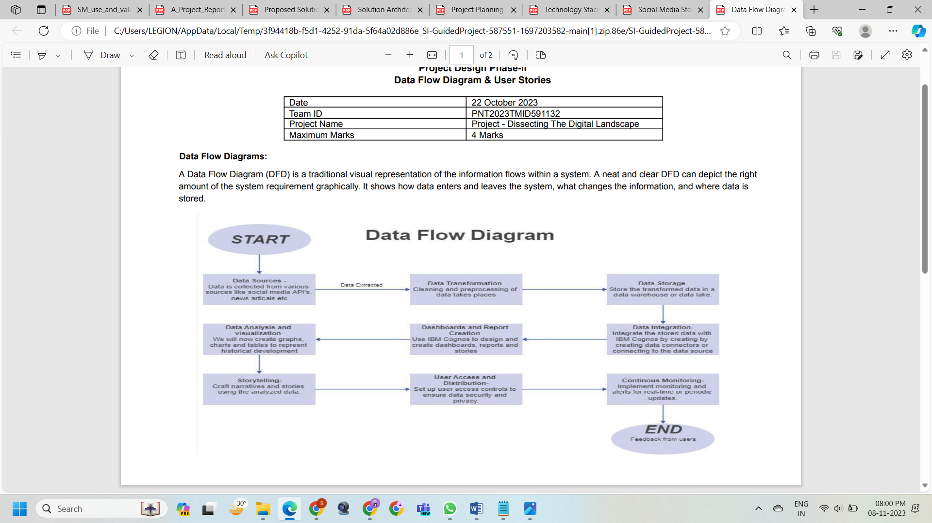

User Stories

Use the below template to list all the user stories for the product

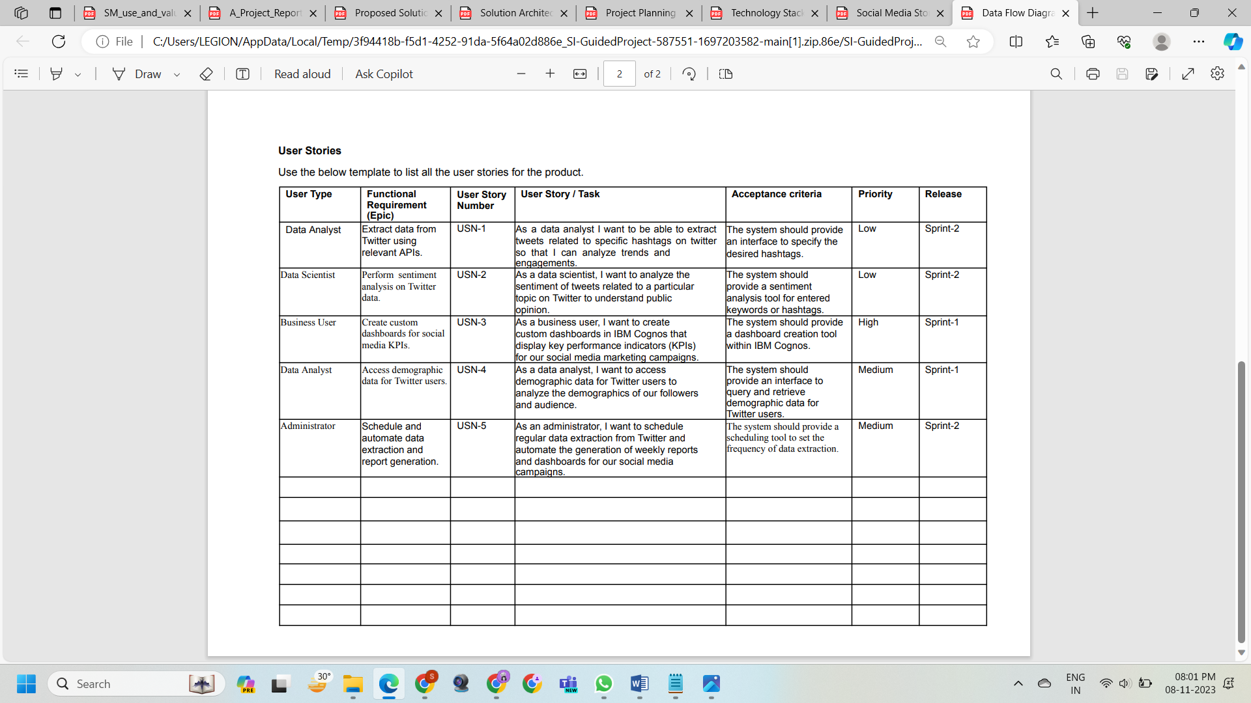

**5.2 Solution Architecture**

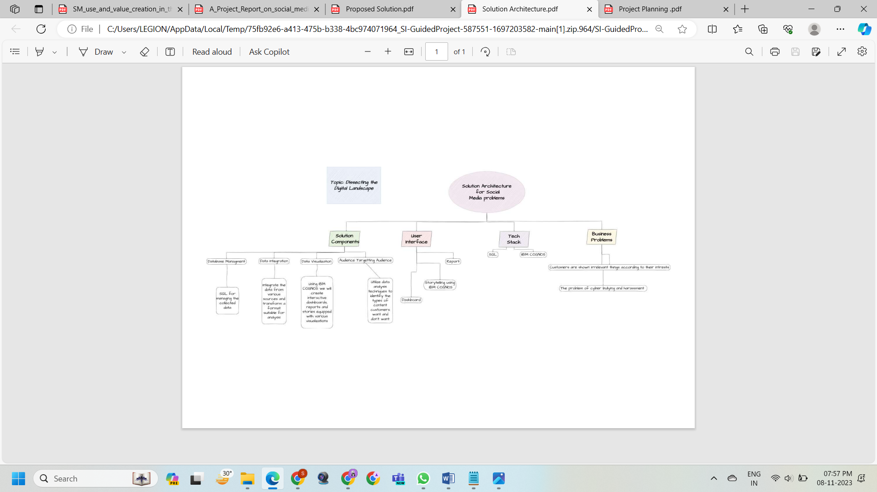

**6. PROJECT PLANNING & SCHEDULING**

**6.1 Technical Architecture**

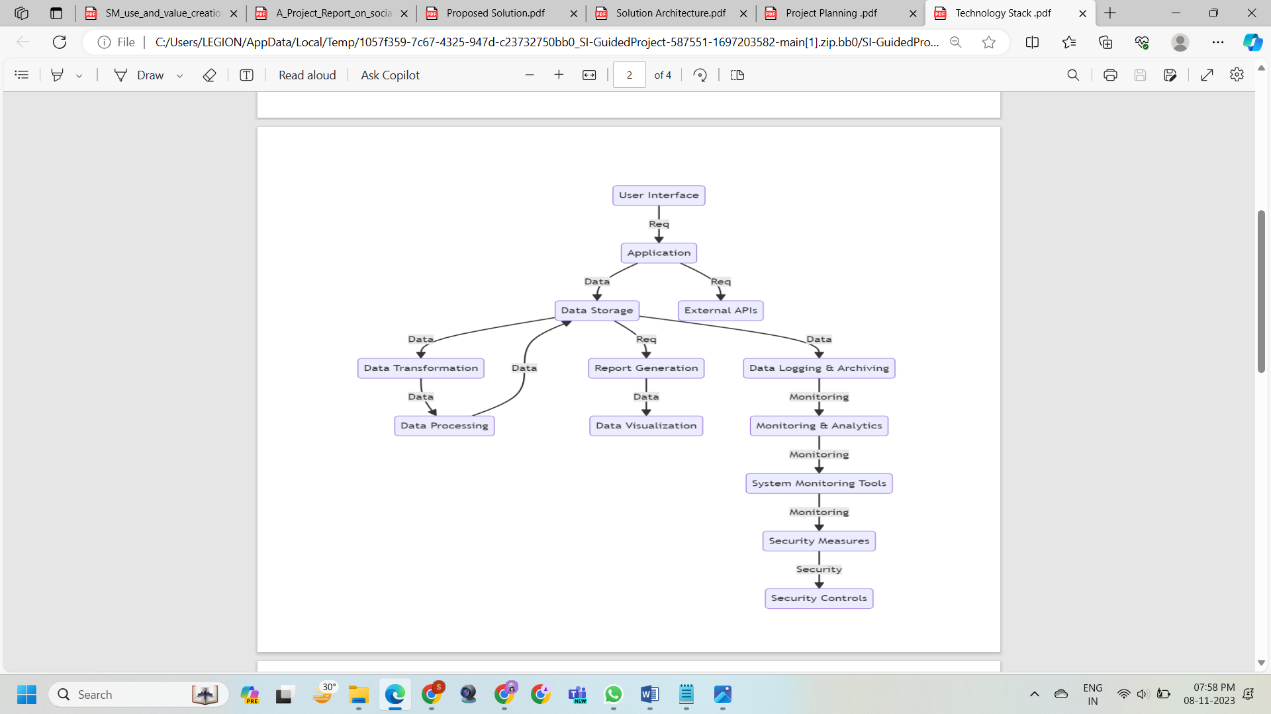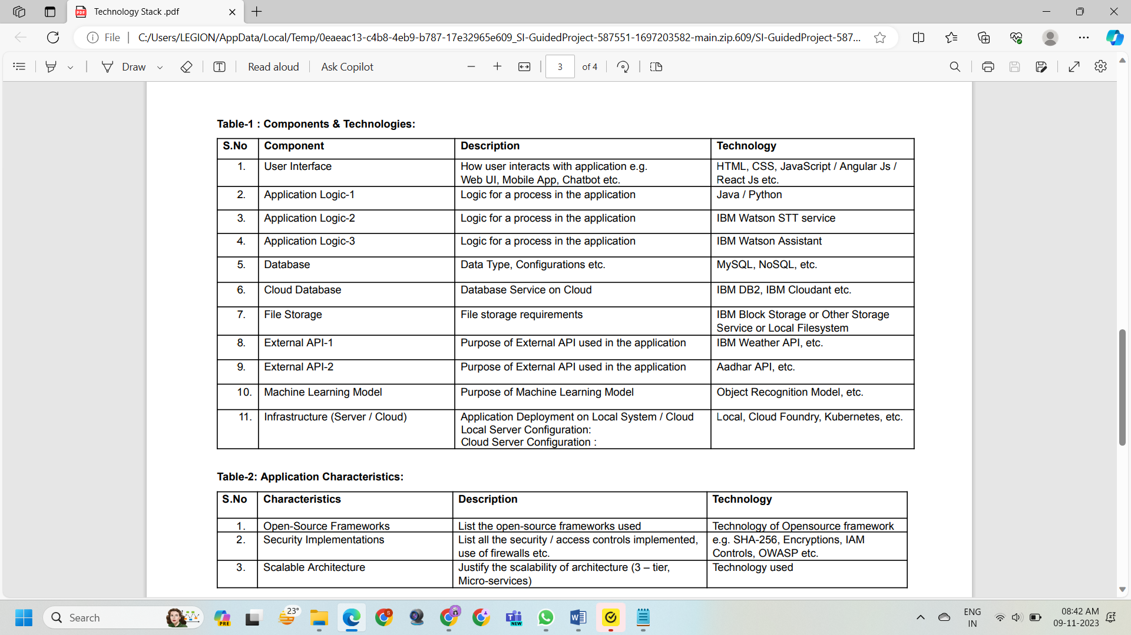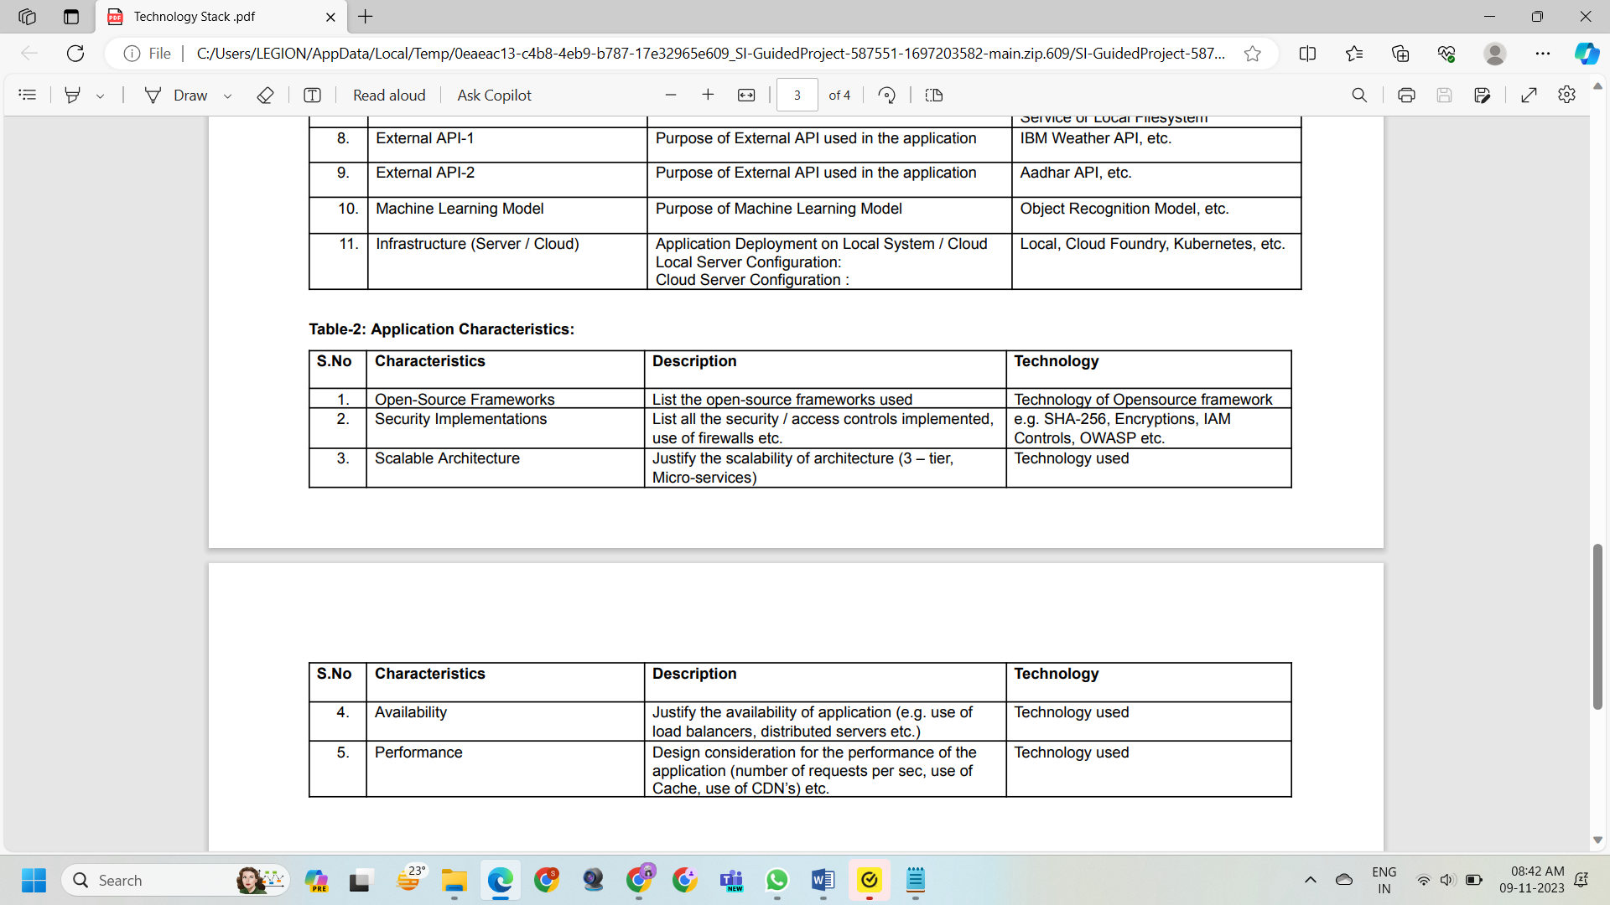

**6.2 Sprint Planning & Estimation**

**6.3 Sprint Delivery Schedule**

**7. CODING & SOLUTIONING (Explain the features added in the project along with code)**

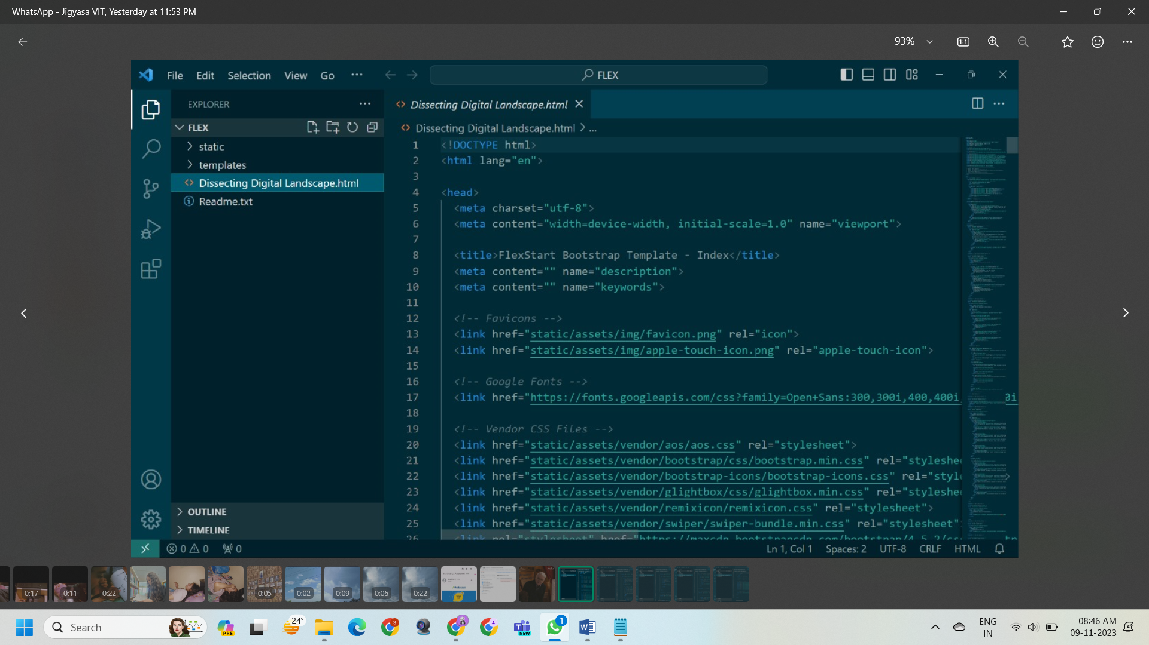 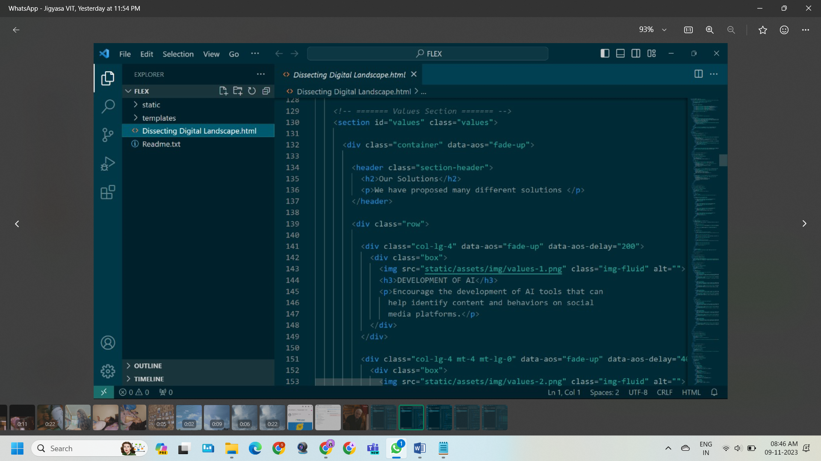 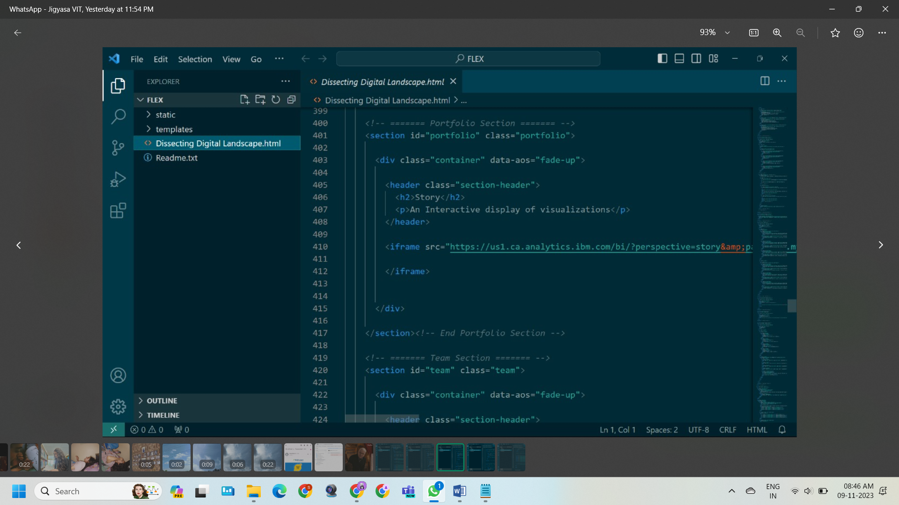 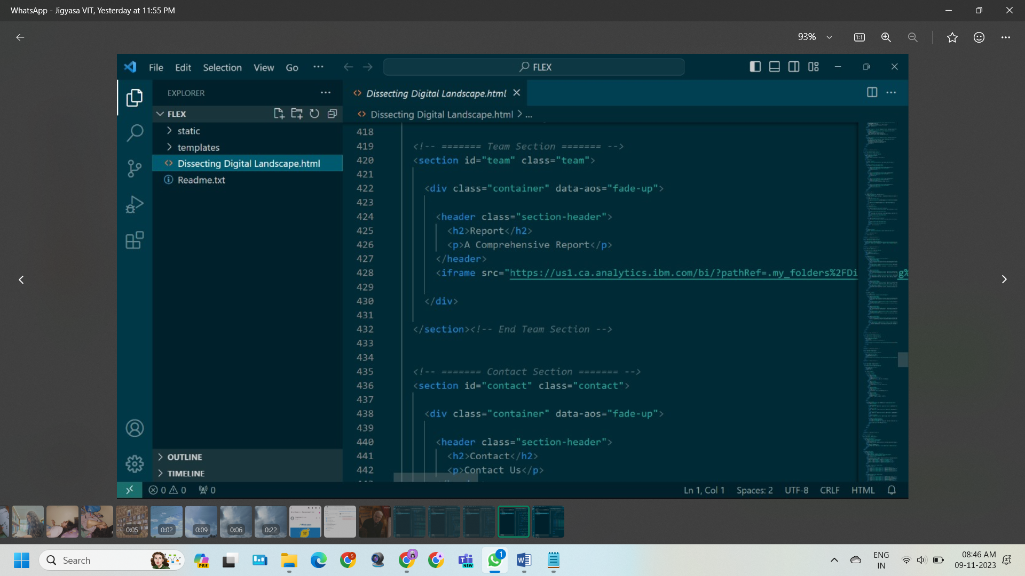 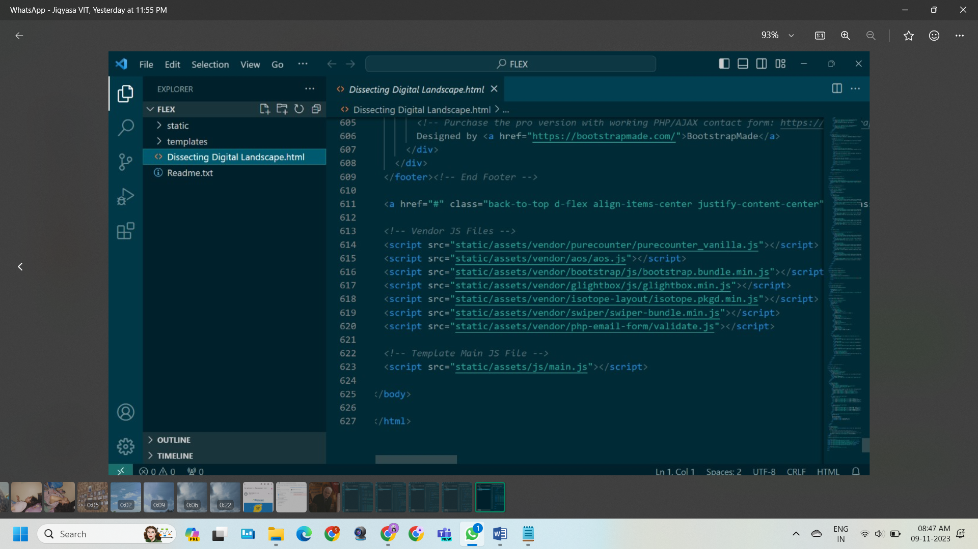

**7.1 Feature 1**

**7.2 Feature 2**

**7.3 Database Schema (if Applicable)**

**8. PERFORMANCE TESTING**

**Model Performance Testing:**

Project team shall fill the following information in model performance testing template.

|  |  |  |
| --- | --- | --- |
| **S.No.** | **Parameter** | **Screenshot / Values** |
|  | Dashboard design |  |
|  | Data Responsiveness |  |
| 4. | Utilization of Data Filters |  |

**8.1 Performace Metrics**

**9. RESULTS**

**9.1 Output Screenshots**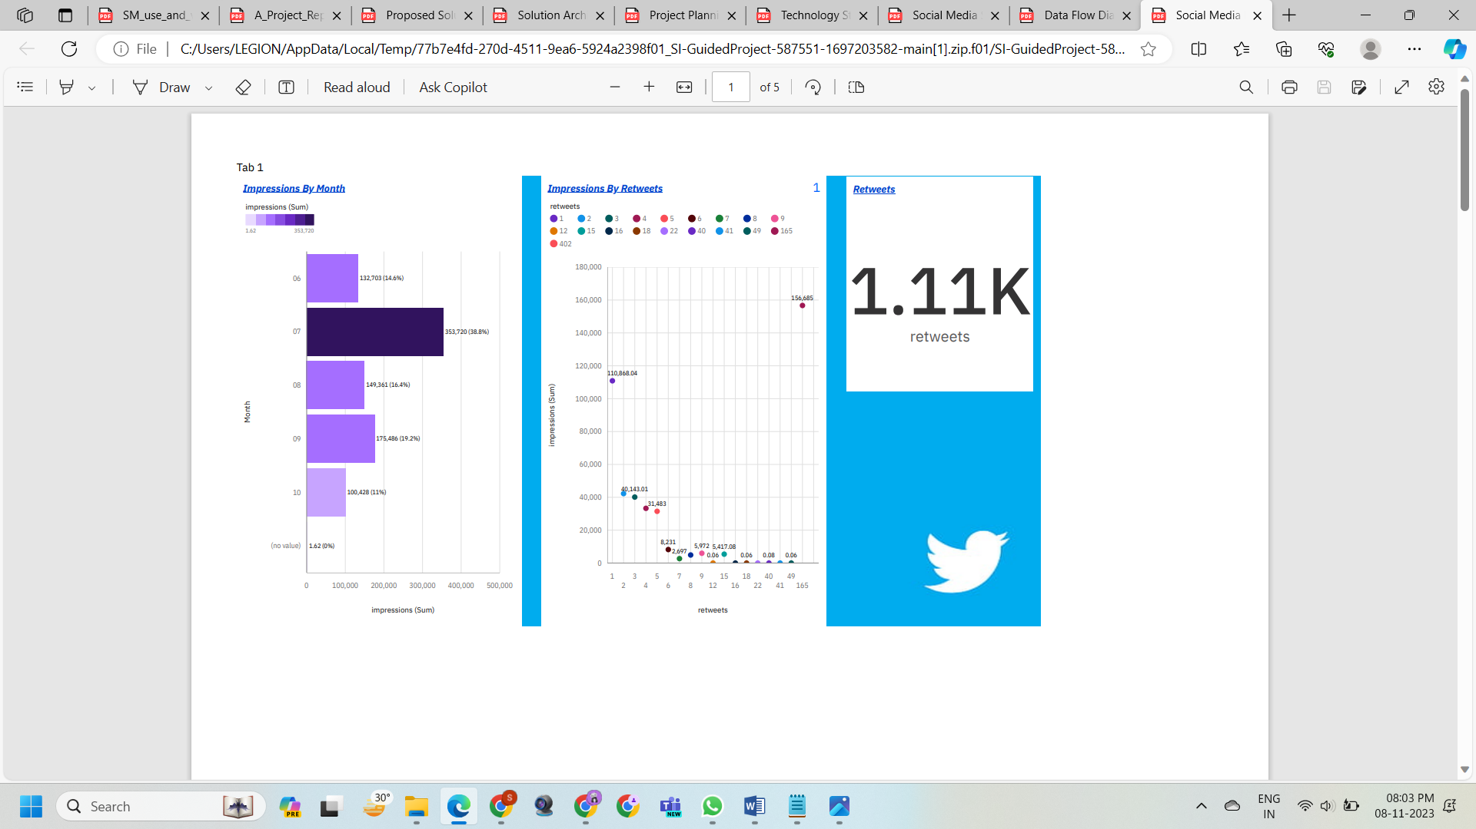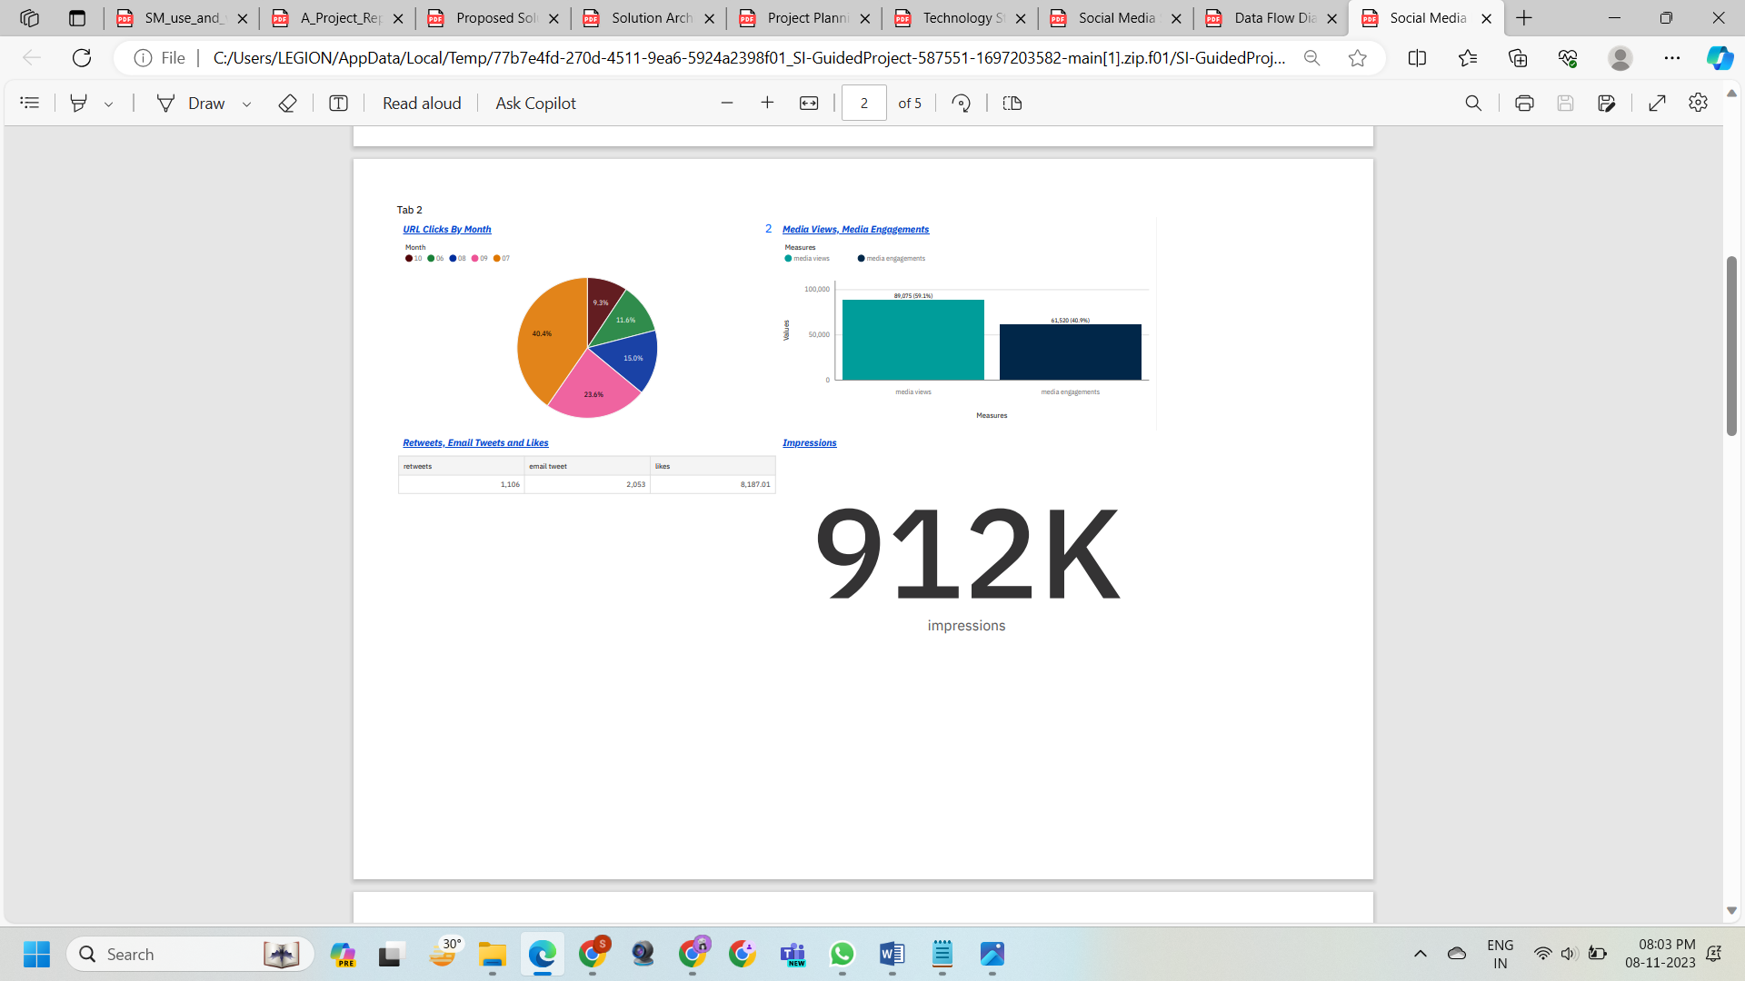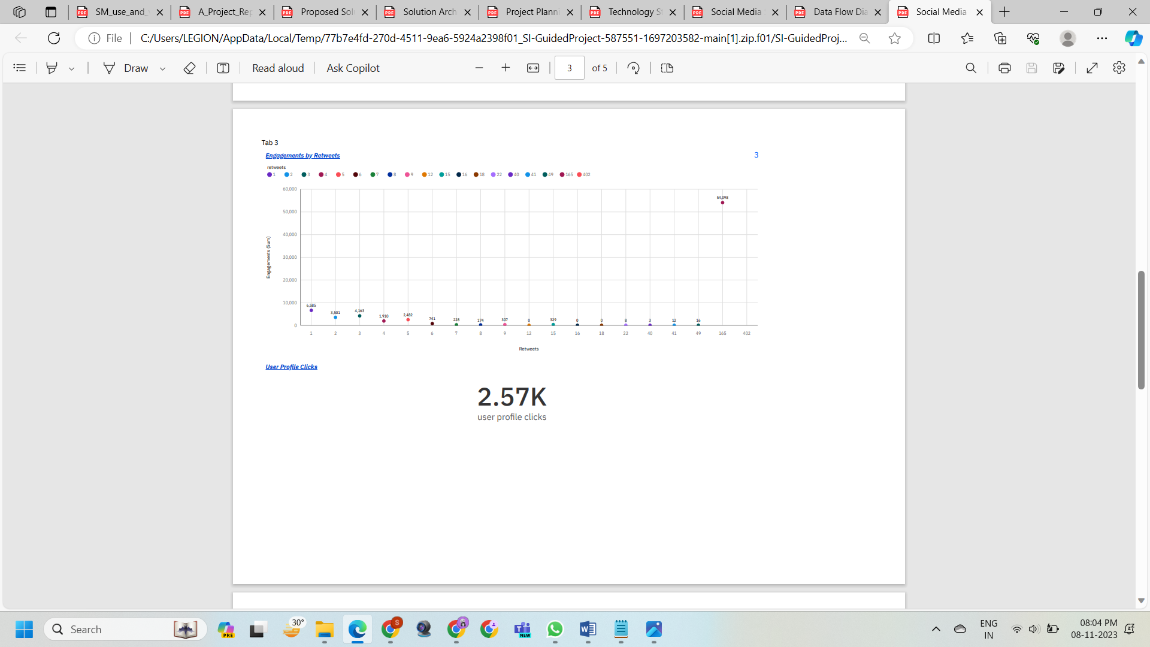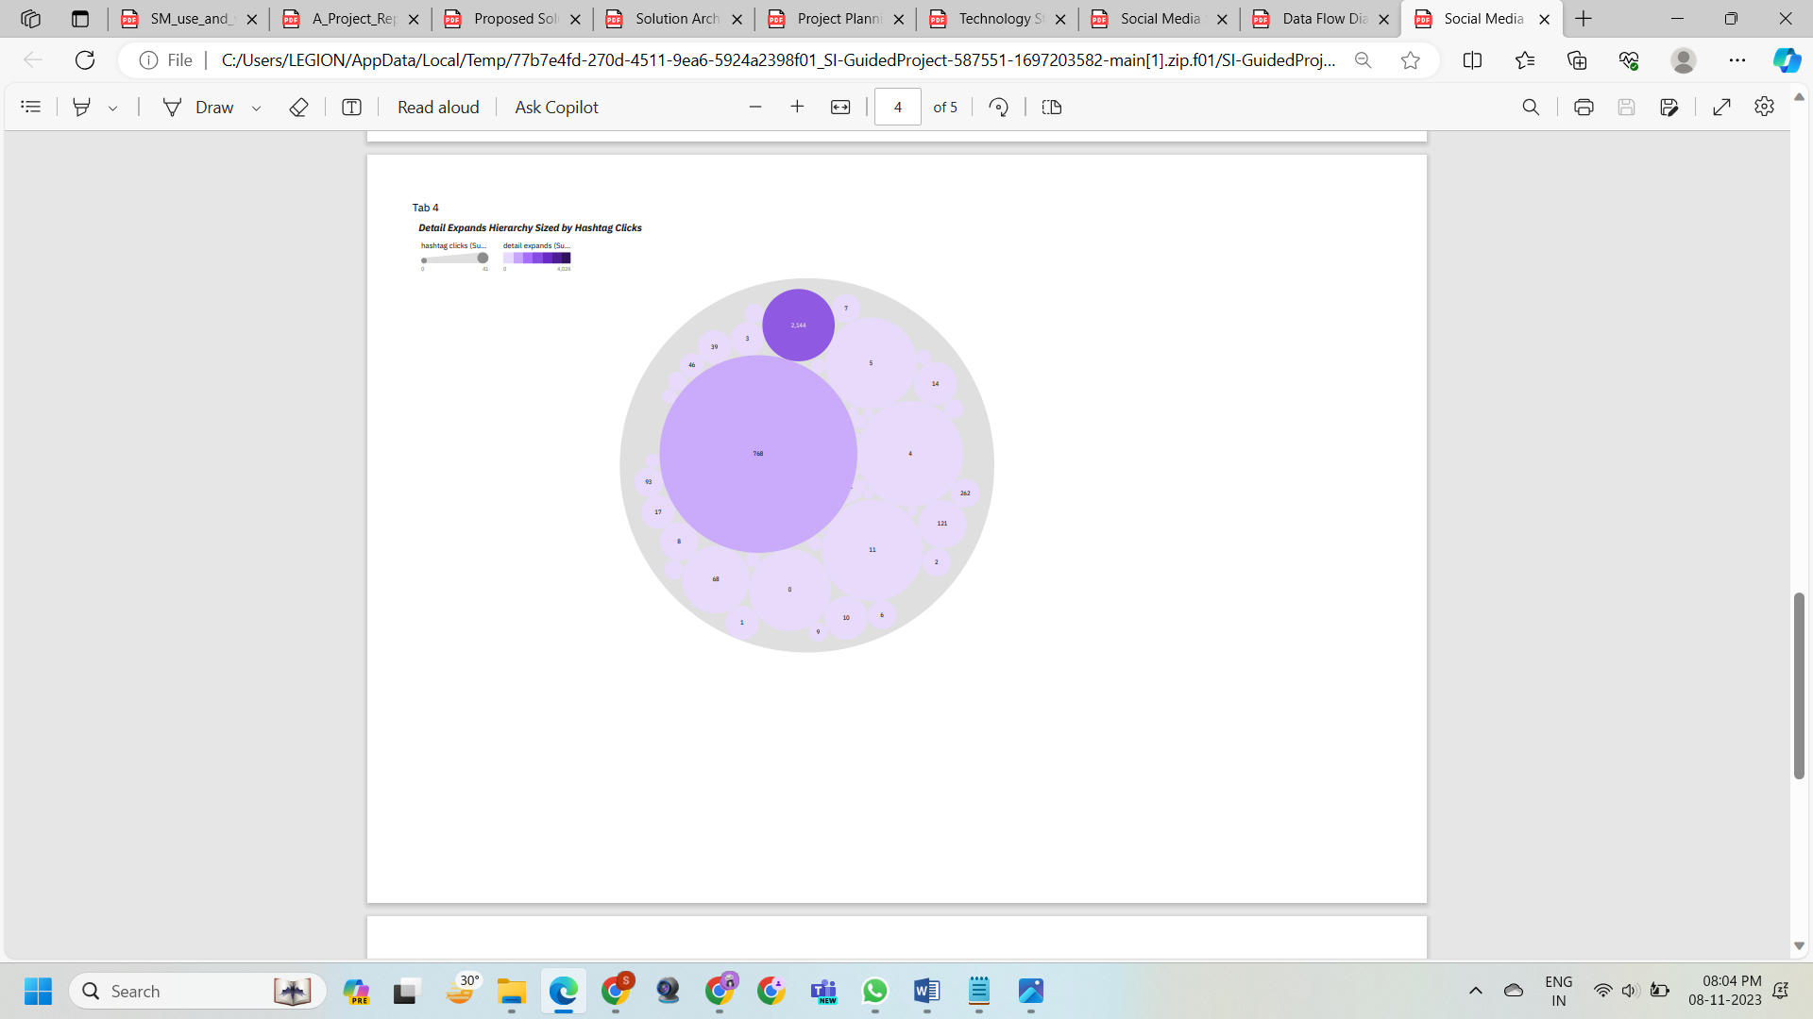

Filter(s) applied to the visualization(s):

Widget 1

retweets Excludes: 0

retweets Excludes: (no value)

Widget 2

Month Excludes: (no value)

Widget 3

retweets Excludes: (no value)

retweets Excludes:0

**10. ADVANTAGES & DISADVANTAGES**

**ADVANTAGES**

Gaining insights into customer preferences and behavior:

Social media analysis can help businesses understand what their customers are talking about, what they care about, and what they are looking for. By understanding customer preferences and behavior, businesses can tailor their products, services, and marketing campaigns to better meet the needs of their customers.

Identifying key trends and emerging topics:

Social media analysis can help businesses identify key trends and emerging topics in their industry. By being aware of these trends, businesses can stay ahead of the competition and make informed decisions about their product development, marketing, and overall business strategy.

Tracking the performance of your social media campaigns:

Social media analysis can help businesses track the performance of their social media campaigns and identify areas for improvement. By understanding which posts and campaigns are most successful, businesses can allocate their resources more effectively and achieve their social media goals.

Uncovering hidden opportunities for growth:

Social media analysis can help businesses uncover hidden opportunities for growth by identifying new customer segments, potential partnerships, and emerging markets. By acting on these insights, businesses can expand their reach and grow their business.

Making informed decisions about your business strategy:

Social media analysis can provide businesses with the data they need to make informed decisions about their business strategy. By understanding the digital landscape and how their customers are engaging with social media, businesses can make better decisions about their product development, marketing, and overall business strategy.

Building stronger relationships with your customers:

Social media analysis can help businesses build stronger relationships with their customers by providing insights into customer needs and concerns. By responding to customer comments and questions promptly and professionally, businesses can demonstrate their commitment to customer service and build trust with their customers.

Additional benefits of dissecting the digital landscape and analyzing social media like Twitter:

* Gain insights into customer preferences and behavior.
* Identify key trends and emerging topics.
* Track the performance of your social media campaigns.
* Uncover hidden opportunities for growth.
* Make informed decisions about your business strategy.
* Build stronger relationships with your customers.

**DISADVANTAGES**

While there are many potential advantages to dissecting the digital landscape and analyzing social media, there are also some potential disadvantages that businesses should be aware of.

Data Quality Issues

Social media data can be noisy and unreliable, with a high volume of irrelevant or misleading information. Businesses need to be careful to clean and validate their data before using it for analysis.

Privacy Concerns

Collecting and analyzing social media data raises privacy concerns, as it can involve personal information about individuals. Businesses need to be transparent about their data collection practices and obtain consent from users whenever possible.

Time and Resource Requirements

Effectively dissecting the digital landscape and analyzing social media requires significant time and resources. Businesses need to have the necessary expertise and infrastructure in place to collect, clean, analyze, and interpret social media data.

Difficulty Drawing Causal Relationships

Social media analysis can provide correlations between variables, but it is difficult to establish causal relationships. Businesses need to be cautious when drawing conclusions from social media data and should consider other sources of information.

Potential for Misinterpretation

Social media data can be misinterpreted, leading to inaccurate conclusions or misguided decisions. Businesses need to be aware of the limitations of social media data and should use it in conjunction with other sources of information.

Ethical Considerations

The use of social media data raises ethical considerations, such as the potential for manipulation, surveillance, and discrimination. Businesses need to use social media data responsibly and ethically.

Over-reliance on Data

While social media data can be valuable, businesses should not over-rely on it to make decisions. They should also consider other sources of information, such as customer feedback, market research, and industry trends.

Difficulty Measuring Impact

It can be difficult to measure the impact of social media analysis on business outcomes. Businesses need to establish clear metrics and goals before embarking on social media analysis projects.

Potential for Bias

Social media data can be biased, reflecting the demographics, interests, and perspectives of the users who generate it. Businesses need to be aware of this bias and take steps to mitigate it.

Dynamic Nature of Social Media

The digital landscape and social media are constantly evolving, making it difficult to keep up with the latest trends and technologies. Businesses need to be adaptable and willing to invest in ongoing training and development.

Despite these potential disadvantages, social media analysis can be a valuable tool for businesses when used effectively. By carefully considering the benefits and risks, businesses can make informed decisions about whether to use social media analysis and how to implement it in a way that minimizes the potential for negative consequences.

**11. CONCLUSION**

In conclusion, dissecting the digital landscape through comprehensive analysis of social media offers a wealth of opportunities and challenges across various domains. This multifaceted endeavor provides businesses, organizations, researchers, and policymakers with valuable insights into the ever-evolving world of online interactions. Through advanced tools, technologies, and methodologies, this analysis allows for a deeper understanding of user behaviors, sentiments, and trends. However, it's essential to approach this task with a balanced perspective, acknowledging both the advantages and disadvantages that come with delving into the vast sea of social media data.

The advantages are substantial. Real-time insights empower swift responses to emerging trends and issues, enhancing strategic decision-making. Corporations can use feedback from customers to improve their marketing and modify their products. Competitive intelligence derived from social media analysis enables informed strategies, fostering innovation and adaptability. Moreover, social media serves as a barometer of public sentiment, influencing political, social, and economic discourse. But there are many obstacles in the way of accomplishing these benefits. Ethical considerations loom large, as data privacy and algorithmic biases demand responsible stewardship of user information. The veracity of the data itself poses a challenge, given the potential for misinformation and the dynamic nature of online content. The analytical complexity, involving sentiment interpretation and network dynamics, calls for sophisticated tools and interdisciplinary expertise. The sheer volume of data necessitates robust infrastructures to ensure effective processing and storage. Moreover, the rapid pace of change in the digital landscape requires ongoing adaptation to platform updates and evolving user behaviors. As the digital landscape continues to evolve, comprehensive analysis of social media will remain a dynamic and indispensable pursuit. By navigating these challenges and capitalizing on the advantages, individuals, businesses, and society at large can leverage social media insights to make informed decisions, drive innovation, and foster meaningful connections in the interconnected world of today and tomorrow

**12. FUTURE SCOPE**

The future scope of dissecting the digital landscape through comprehensive analysis of social media holds immense potential, driven by advancements in technology, changing user behaviors, and the growing importance of digital interactions. Here are some key areas of future development:

1. Real-time analytics and insights:

Social media analytics tools are becoming increasingly sophisticated, enabling real-time analysis of data as it is generated. This allows businesses to gain immediate insights into customer sentiment, brand perception, and emerging trends.

1. Artificial intelligence (AI) and machine learning (ML):

AI and ML are being used to develop more powerful social media analytics tools that can automatically identify patterns, trends, and anomalies in data. This can help businesses to uncover hidden insights that would otherwise be difficult to find.

1. Natural language processing (NLP):

NLP is being used to analyze the sentiment of social media posts, identify key topics, and extract information from unstructured data. This can help businesses to better understand their customers' needs and wants.

1. Augmented reality (AR) and virtual reality (VR):

AR and VR are being used to create immersive social media experiences that can be more engaging and informative. This can help businesses to reach new audiences and build stronger relationships with existing customers.

1. Multimodal analysis:

Social media analytics tools are increasingly incorporating data from multiple sources, such as social media posts, images, videos, and audio. This can provide a more comprehensive understanding of user behavior and preferences.

1. Predictive analytics:

Social media analytics tools are being developed that can use historical data to predict future trends and events. This can help businesses to make better decisions about their marketing and product development strategies.

1. Privacy and security:

As social media continues to grow in popularity, so does the need for privacy and security. Businesses need to be careful about how they collect and use social media data, and they need to take steps to protect user privacy.

1. Ethical considerations:

As social media becomes more powerful, it is important to consider the ethical implications of using social media data. Businesses need to use this data responsibly and in a way that benefits society.

1. Integration with other data sources:

Social media data is increasingly being integrated with other data sources, such as customer relationship management (CRM) data and website analytics data. This can provide a more holistic view of the customer and their journey.

1. Global reach:

Social media is a global phenomenon, and businesses need to be able to analyze social media data from around the world. This requires the use of tools that can handle large amounts of data from multiple languages and cultures.

These are just a few of the key areas of future development in the field of social media analytics. As technology continues to evolve, we can expect to see even more innovative and powerful tools that can help businesses to extract valuable insights from social media data.